D.K.T.E. Society’s Textile and Engineering Institute, Ichalkaranji.

**(An Autonomous Institute, Affiliated to Shivaji University, Kolhapur)**

**Accredited with ‘A+’ Grade by NAAC**

Department of Computer Science & Engineering

2020-2021



Internship Report

**Full Stack Web Programming Development Internship at PHN Technology PVT. LTD, Pune.**

**Name: Neha Mahajan**

**PRN: 18UCS063**

**Abstract**

This report is being presented as a part of ----- course . This report includes the details of the internship done as a part of winter internship process of the DKTE’s Textile and Engineering Institute, Ichalkaranji curriculum.

This internship process was 15 days long

During which we got a chance to learn about Full Stack Web Development Programming. The technologies used during this internship were HTML, CSS, Bootstrap, JavaScript, JQuery and AngularJS and Laravel.

We were supposed to work on these mentioned technologies under the guidance of mentors.

**Index**

|  |  |  |
| --- | --- | --- |
| **Sr no.** | **Name** | **Page number** |
| 1 | About Company |  |
| 2 | Company Division |  |
| 3 | Technologies Introduced |  |
| 4 | Working Methodology |  |
| 5 | About the projects |  |
| 6 | About my role |  |
| 7 | Conclusion |  |

**About the company**

**PHN Technology** is a one stop solution or all your business needs. Let your business be related to technology, a mechanical workshop, a law firm, a consultancy firm or coaching classes, you will need a website to publish your data to the world.

Also nowadays mobile applications are a popular way to become popular among users. PHN Technology is available to do all this stuff for you. Just visit them and all your technical tensions are our's. They will provide you the best possible result.

**Company Division**

The company has two divisions:

1. Training Division
2. Project Handling Division

The training division gives training on various aspects regarding Full Stack Web Development Programming.

The other division viz. Project handling division takes big projects to complete and also to real-time data analysis.

**Tools Used**

1. HTML
2. CSS
3. BOOTSTRAP
4. JAVASCRIPT
5. JQUERY
6. ANGULARJS
7. LARAVEL

**Working Methodology**

I was supposed to work on Sublime Text Editor/ VS code to run given assignments and projects. I used Sublime Text 3 Editor during my internship period. Using this editor I created a Portfolio website, login forms, Carousels, cards, js-forms, navbars and tables etc.

They used to give me some problems as a classwork and some as homework. That was helpful to improve our skills and confidence.

Also they had focused on enhancing our search skills to explore more and more about given technology.

They used to teach us some basic concepts about related topics and they give some problem statements to implement those topics. This method was continued throughout the internship program. Each new day we were introduced to a new technology/topic. That helps me to gain more and more knowledge in Full Stack Web Development Programming.

After completion of internship they conducted webinars on Android App Development and Data Structure courses. Also they shared some tutorials and courses on HTML,CSS and Bootstrap with us.

**About the projects**

They used to give us daily assignments and problem statements during lectures. Also we had done one mini-project by merging all the technology introduced during the internship.

**Here is a glimpse of the projects/assignment covered in internship program:**

**1: Make Google Homepage using HTML, CSS**.

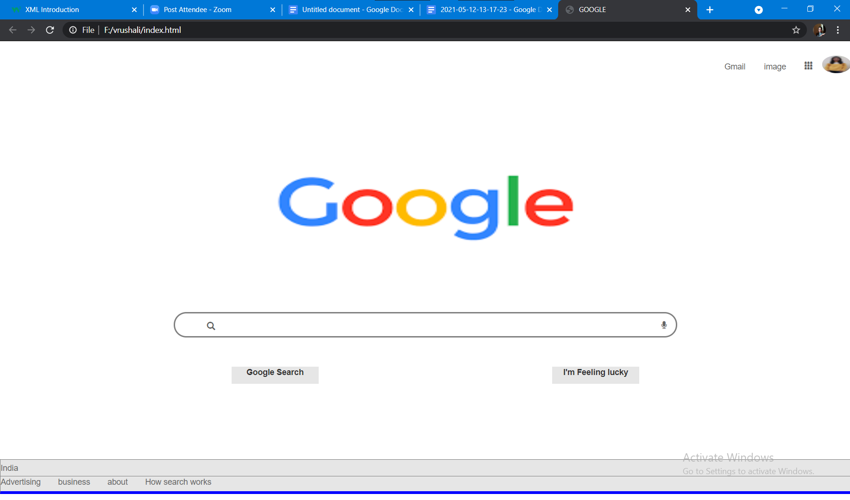

**2:- Create Navbar Using Bootstrap**

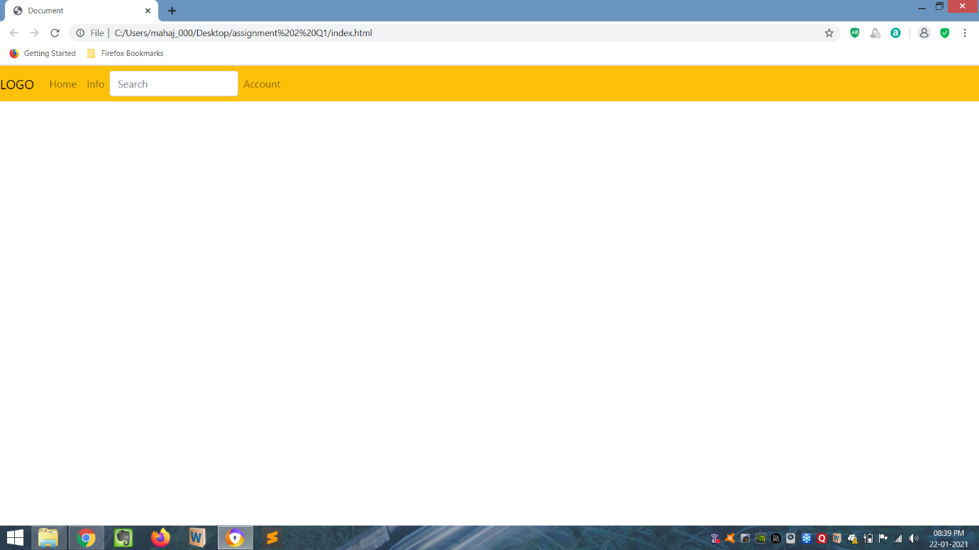

**3:- Use PHP Functions**

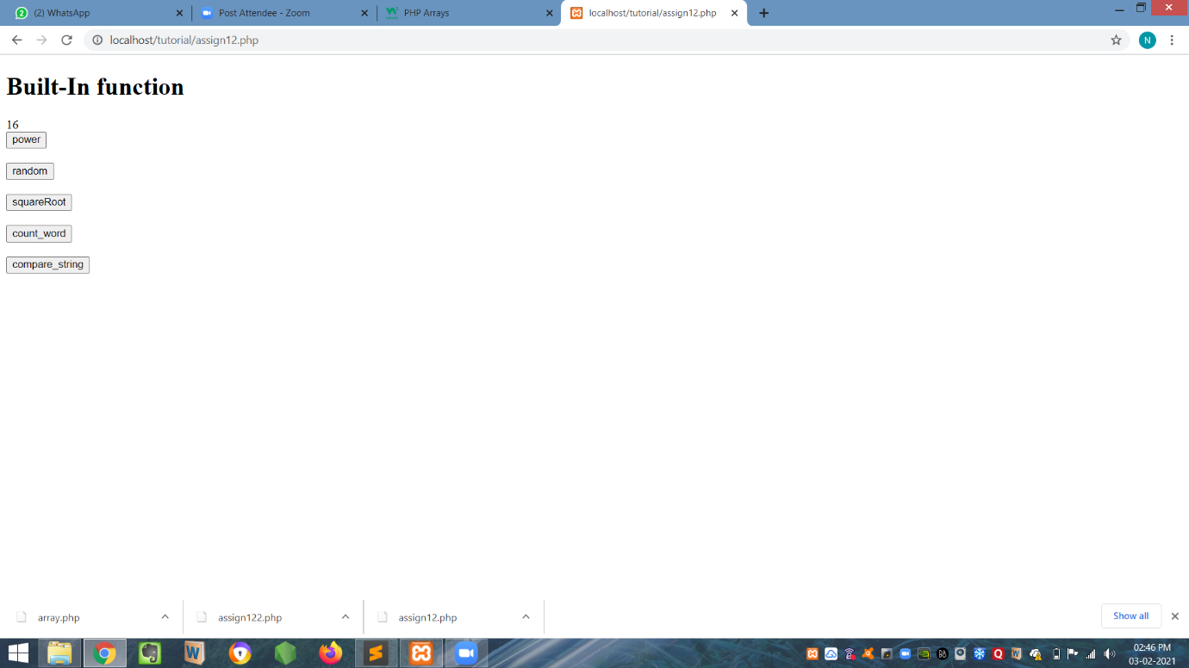

**4:- Create Multidimensional Array Using PHP**

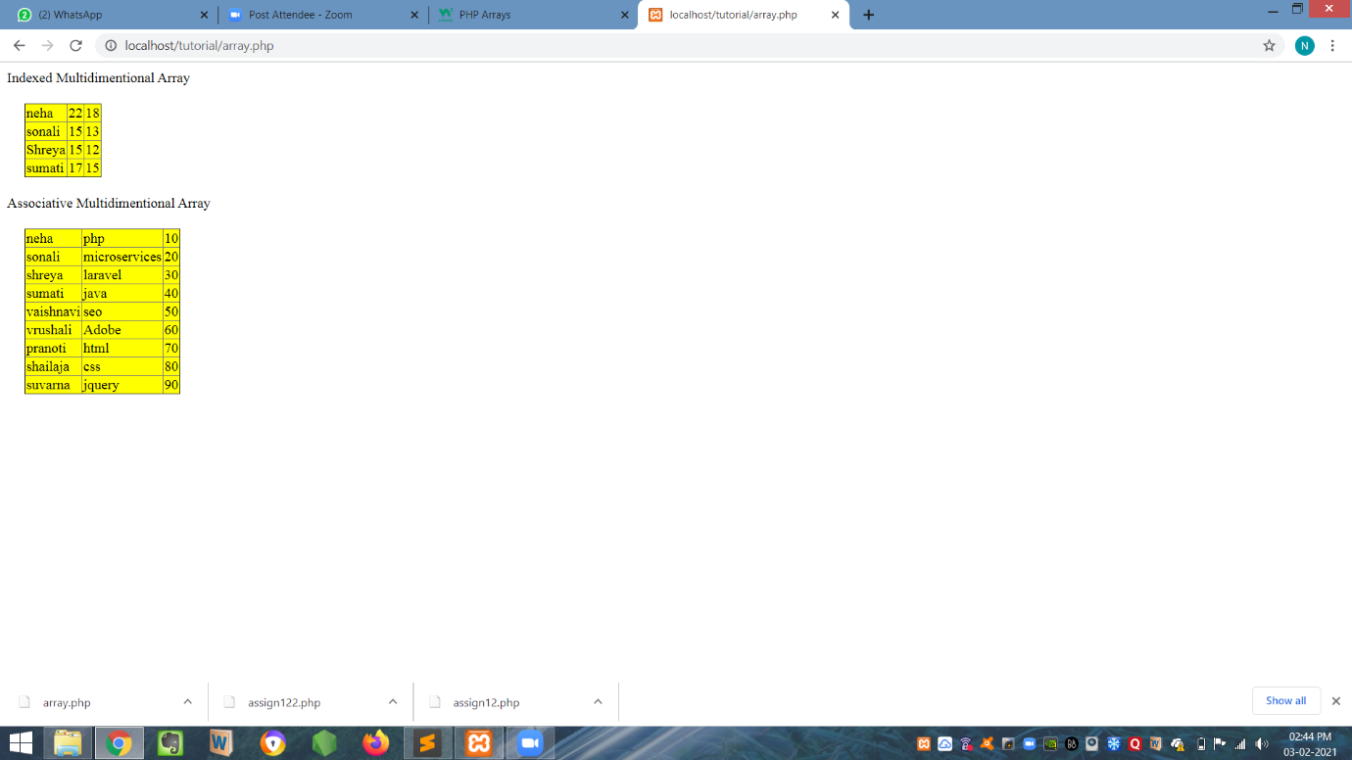

**5:- Create Form Using PHP**

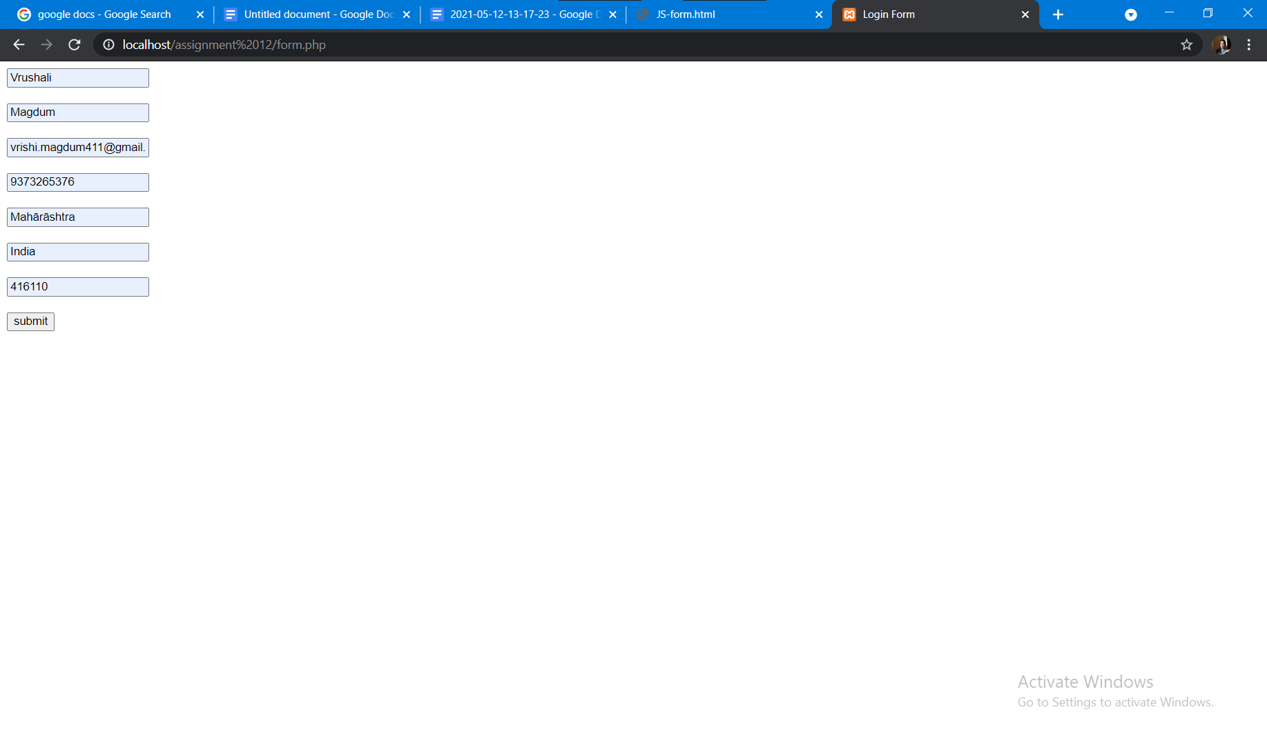

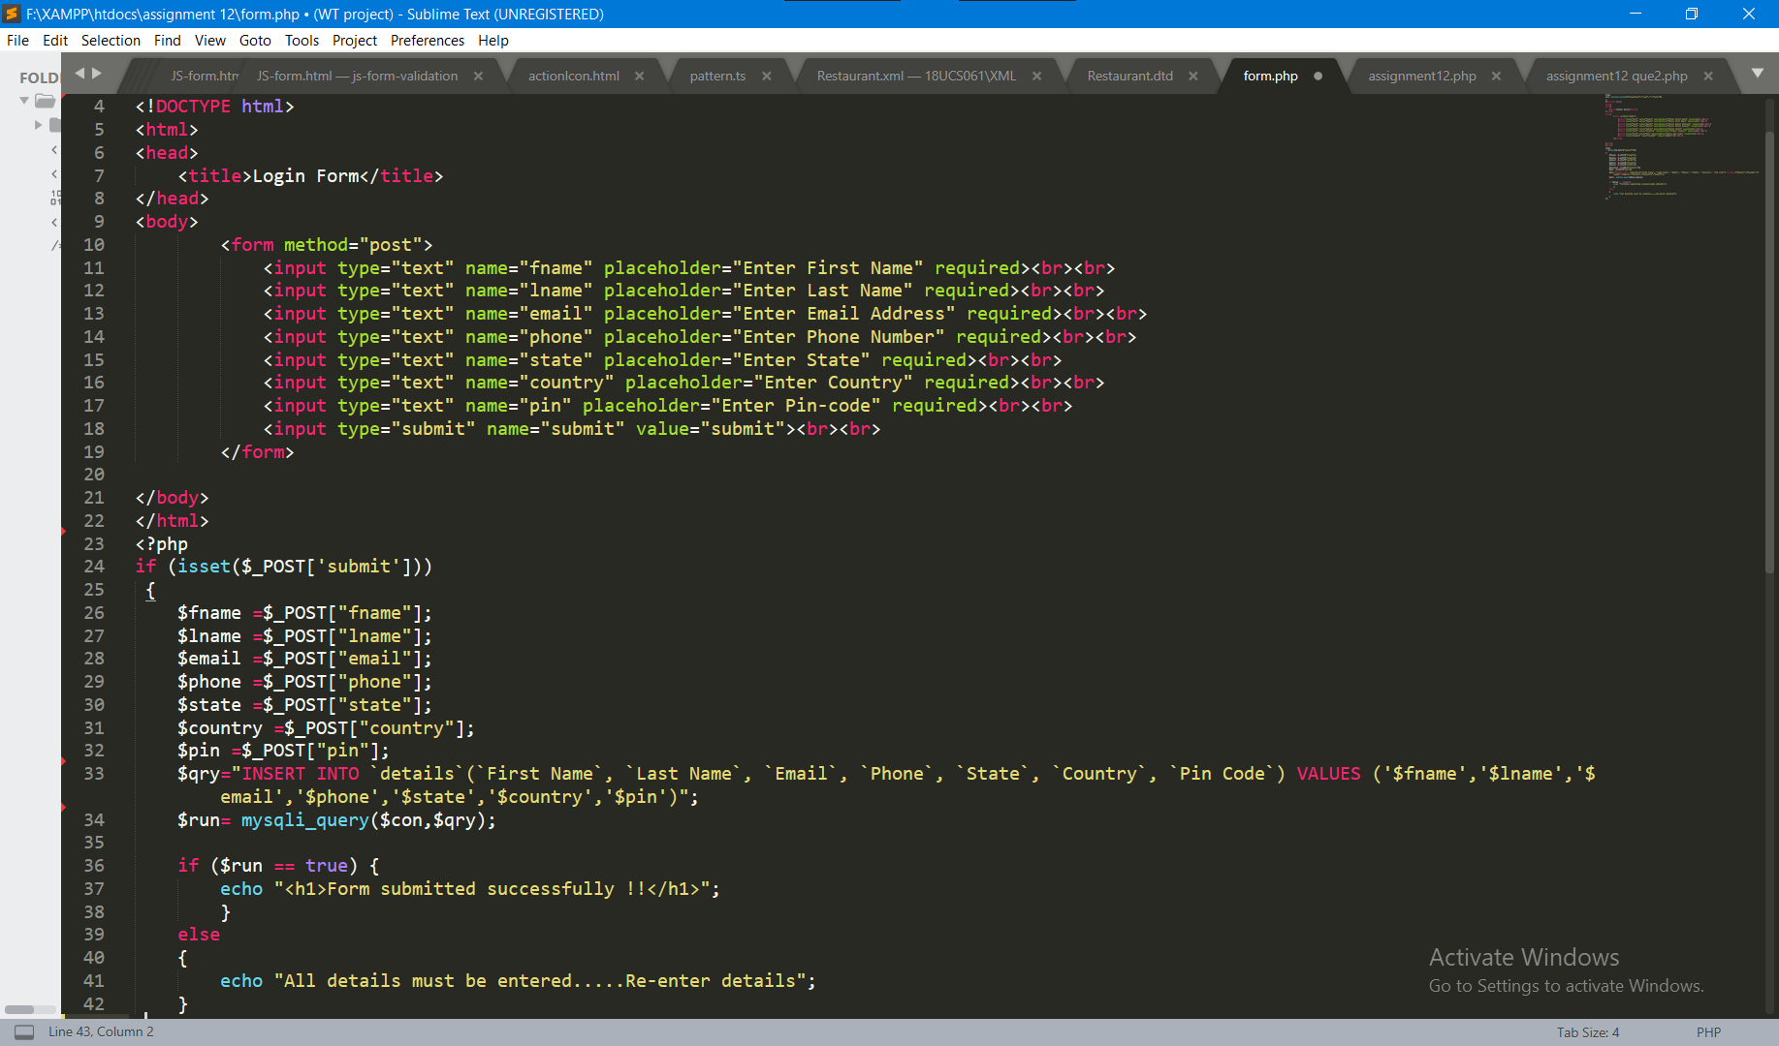

**6:- Create Striped Row Form Using Bootstrap**

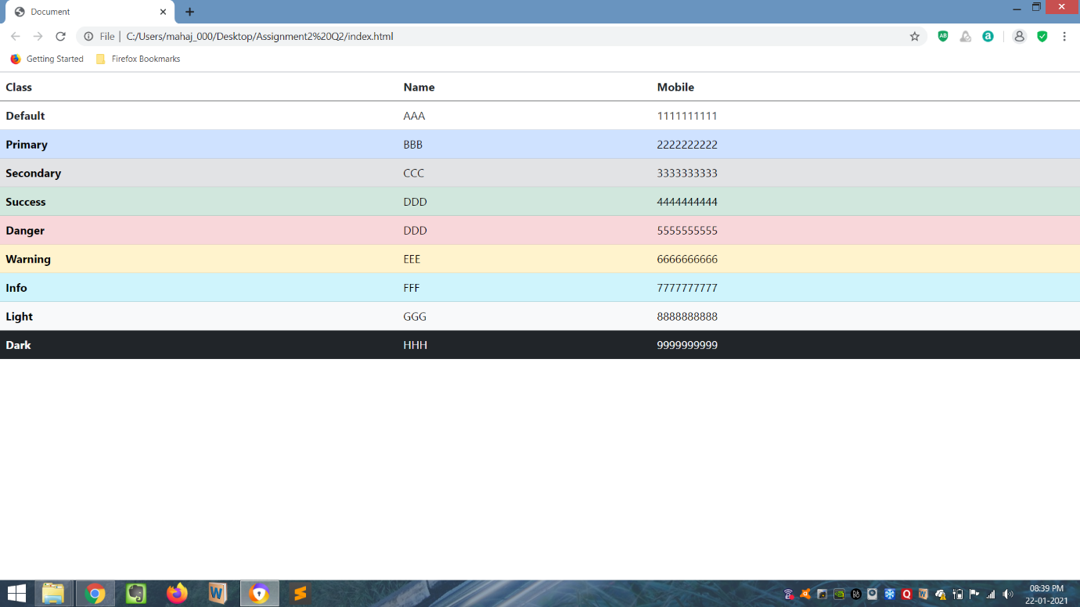

**7:- Create Simple form using JavaScript**

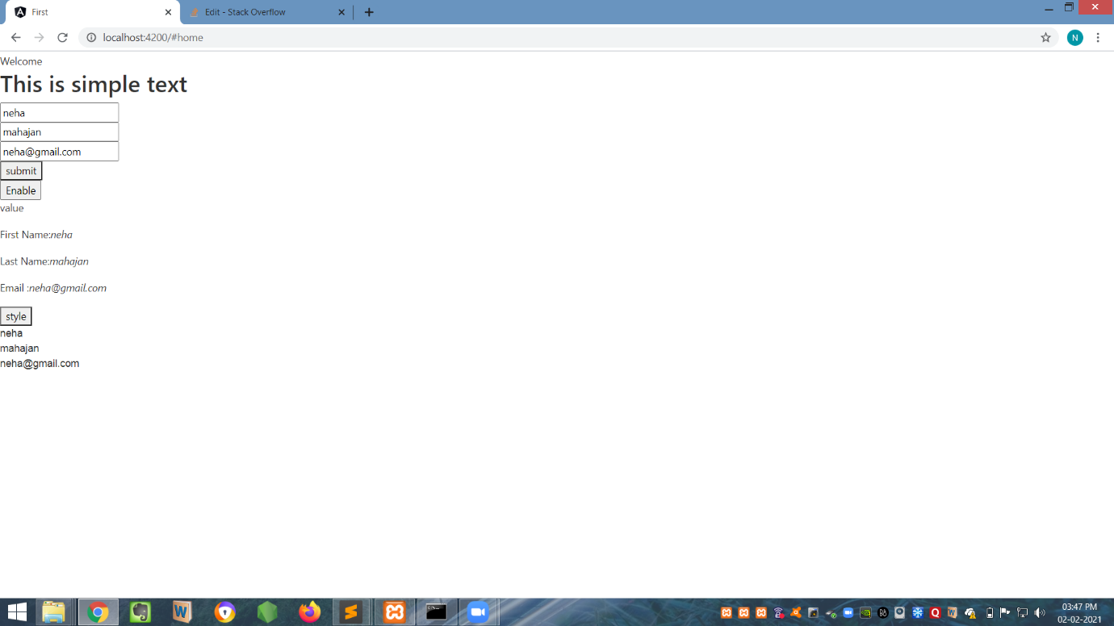

**8:- Action Icon Buttons using Bootstrap**

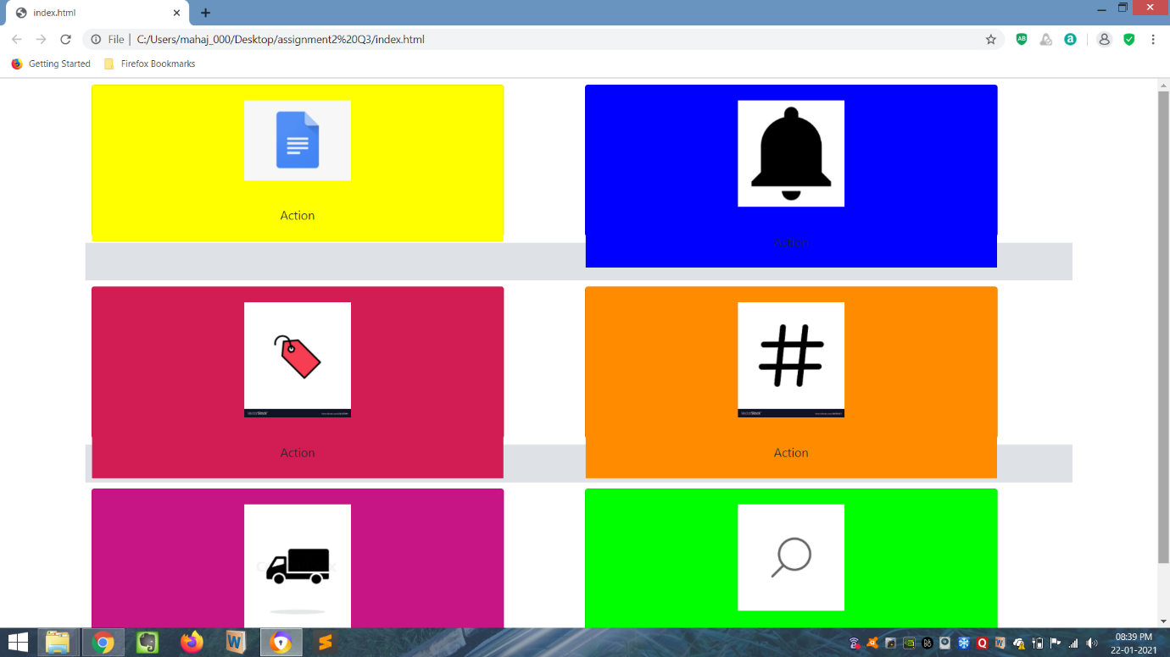

**9:- Key Events using AngularJS**

|  |  |
| --- | --- |
|  |  |

**10:- Create a form Using AngularJS**

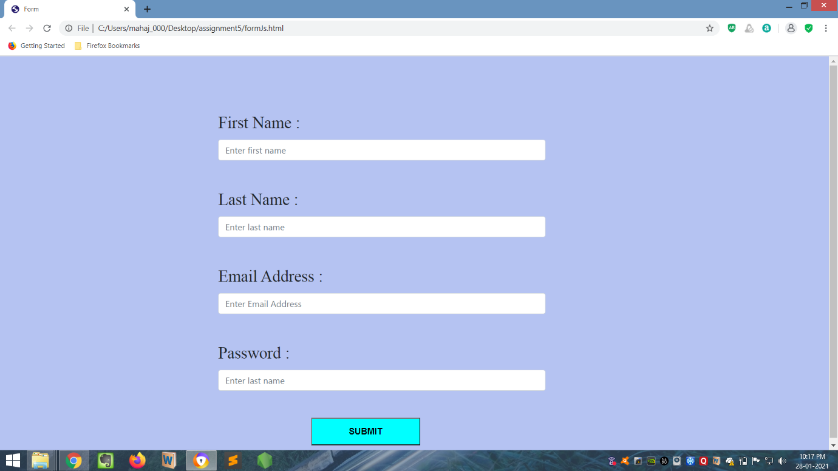

**Mini Project**

During this internship we were supposed to do one mini-project. This project is related to creating a portfolio website for yourself.

We were supposed to use HTML,CSS, BOOTSTRAP, PHP, and JAVASCRIPT. I created one one portfolio website which includes 4 pages that are home page, resume page, about page and contact me page respectively. Overall we practically learned to connect different technology used in Full Stack Web Development Programming. This project motivated me to create more and more websites.

**About my work**

I did my work with sincerity. I learned the new technologies like AngularJs and PHP that the trainers of PHN Technology have taught me. To solve their given tasks and complete the given projects I used my knowledge efficiently.

**Conclusion**

Full Stack Web Development has to work on building front-end and backend-websites using different programming languages like HTML, CSS, BOOTSTRAP, JS, ANGULAR, ANGULARJS, PHP and LARAVEL.

The website we are going to build should be responsive; as we can use that website on different machines.